Creating PARCC-Like Assessments
Grade 4

Evidence Based Selected Response Questions (EBSR)
These types of questions combine a traditional selected-response question with a second selected-response question that asks students to show evidence from the text that supports the answer they provided to the first question.

- Skill: Academic Vocabulary

Part A Question:
What is the meaning of the word _____________________ as it is used in the story (Title of story).
a.
b.
c.
d.

Part B Question:
Which detail from the story best supports the answer to Part A?
a.
b.
c.
d.

Evidence Based Selected Response Questions (EBSR)
(Continued)

- Skill: Identifying Themes
Part A:
Which statement best expresses one of the themes to the story?
a.
b.
c.
d.
Part B Question:
Which detail from the story provides the best evidence for the answer to Part A?
a.
b.
c.
d.

Part A Question:
How are the events in paragraphs 1 and 2 important to the theme of the story?
(Give multiple choices)

Part B Question:
Which sentence from the story provides the best support for the answer in Part A?
(Give multiple choices)

Technology-Enhanced Constructed Response Questions (TECR)
These types of questions use technology to capture student comprehension of texts in authentic ways (drag and drop, cut and paste, shade text, move items to show relationships).

You can design questions to simulate TECR questions.

Skill: Summarizing
Create a summary of the story using three of the sentences listed here. Write the three sentences that describe key ideas from the story into the boxes titled “Summary.” The sentences should describe key ideas from the story in the order that they happen.

a.
b.
c.
d.
e.

Summary

Skill: Setting
Select 3 phrases that help describe the setting from the column titles “Phrases that Describe the Setting” and 3 pieces of supporting evidence from the column titled “Evidence from story”

Phrases that Help Describe the Setting | Evidence from the Story

Skill: Story Elements
Question:
Write 3 details from the list below that describes the setting of the story and place them in the graphic organizer (Web)
. 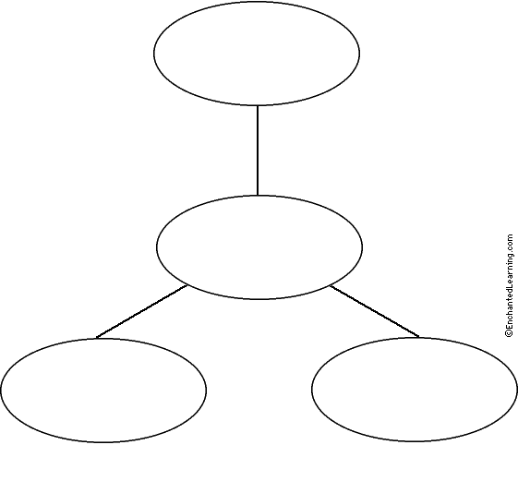

Skill: Main Idea
Write 3 details that support the main idea from the story and write them along with the main idea in the web.

